**Calculator Assumed**

**Topic: Mixed Trigonometry Applications**

Time: 45 minutes

Total Marks: 45

Your Score: / 45



**Question One: [5 marks]**

The area of an obtuse isosceles triangle with equal side lengths of 12 cm is .

Determine the length of the third side.

**Question Two: [3 marks]**

Prove that 

**Question Three: [6 marks]**

Show, with algebraic reasoning, that 

**Question Four: [6 marks]**

A and B are both acute angles such that  and .

Determine the exact value of 

**Question Five: [8 marks]**

Calculate the area of the shaded region if it is known that the length of AB is 5 cm.



**Question Six: [1, 6, 4 = 11 marks]**

A cyclic quadrilateral, ABCD, has , ,  and .

Calculate:

1. the size of angle .
2. the size of angle .
3. the area of the quadrilateral.

**Question Seven: [4, 2 = 6 marks]**

A Ferris wheel has a diameter of 40m, with the centre 22m above the ground.

Customers riding the Ferris wheel, climb a few stairs and get on a carriage at the lowest point of the wheel.

The wheel makes one rotation every 120 seconds.

1. Draw a sketch of one rotation of the Ferris wheel from when a customer steps onto the ride.

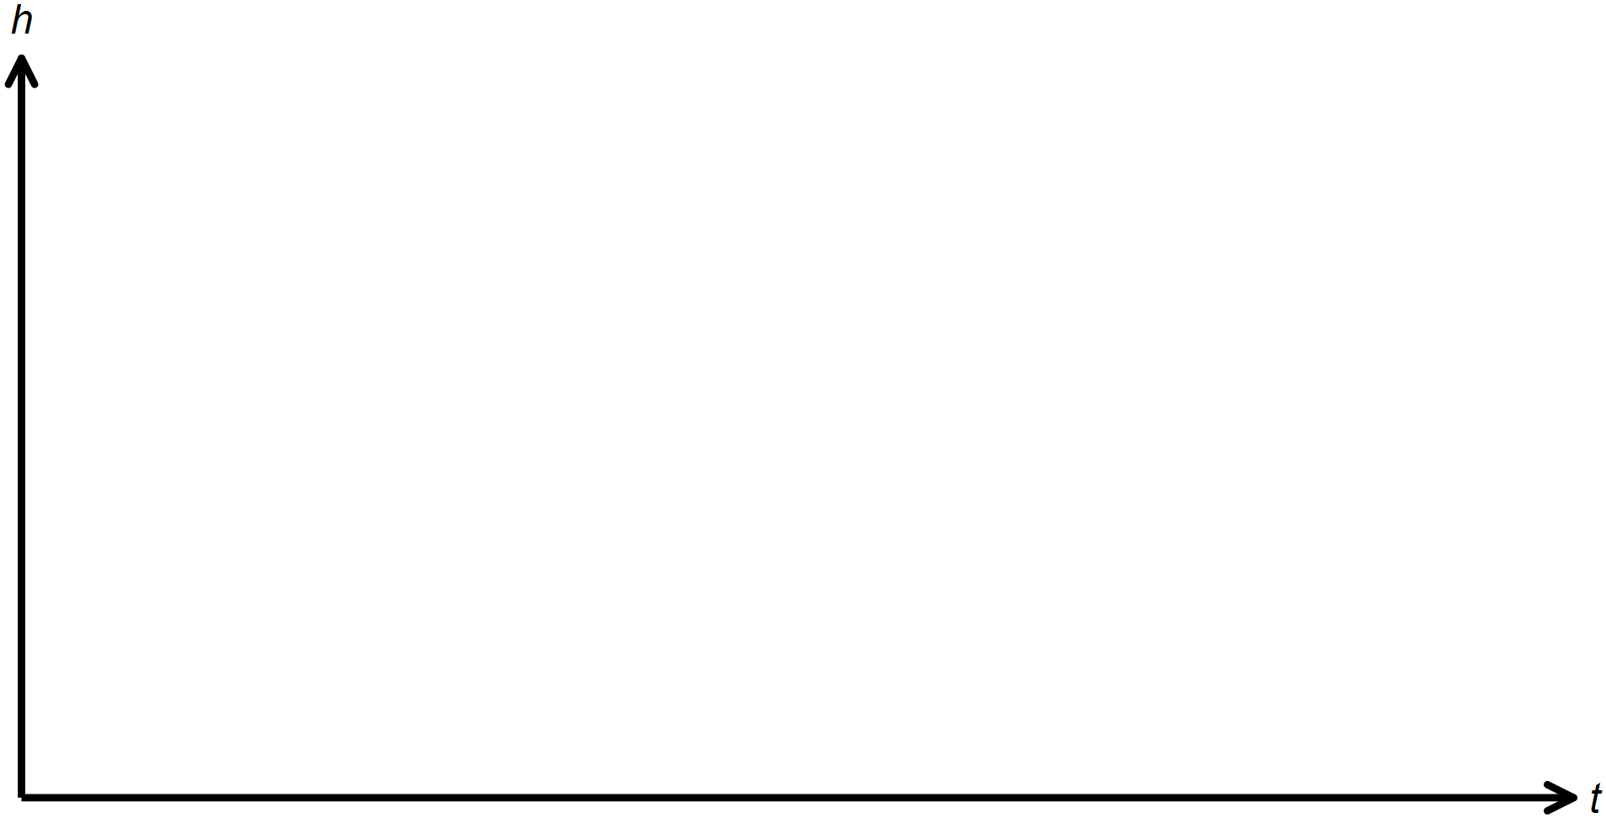

1. Hence or otherwise find the cosine equation of the graph.

**SOLUTIONS**

**Calculator Assumed**

**Topic: Mixed Trigonometry Applications**

Time: 45 minutes

Total Marks: 45

Your Score: / 45



**Question One: [5 marks]**

The area of an obtuse isosceles triangle with equal side lengths of 12 cm is .

Determine the length of the third side.



**Question Two: [3 marks]**

Prove that 



**Question Three: [6 marks]**

Show, with algebraic reasoning, that 









**Question Four: [6 marks]**

A and B are both acute angles such that  and .

Determine the exact value of 





**Question Five: [8 marks]**

Calculate the area of the shaded region if it is known that the length of AB is 5 cm.













**Question Six: [1, 6, 4 = 11 marks]**

A cyclic quadrilateral, ABCD, has , ,  and .

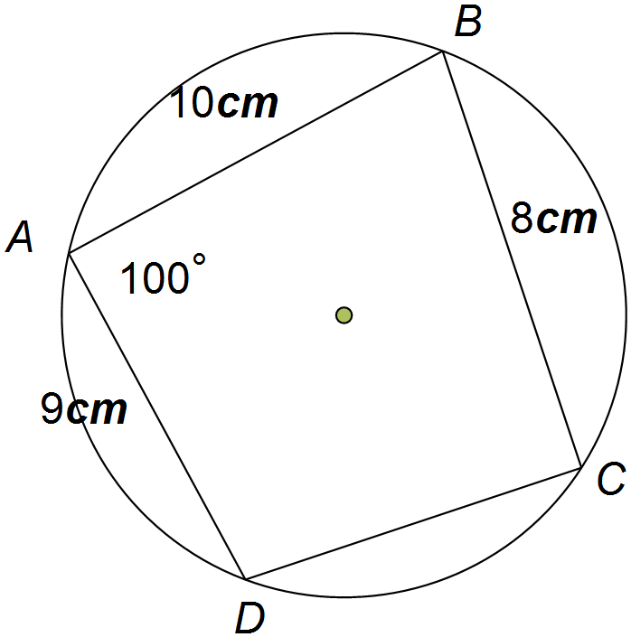Calculate:

1. the size of angle .





1. the size of angle .



1. the area of the quadrilateral.





**Question Seven: [4, 2 = 6 marks]**

A Ferris wheel has a diameter of 40m, with the centre 22m above the ground.

Customers riding the Ferris wheel, climb a few stairs and get on a carriage at the lowest point of the wheel.

The wheel makes one rotation every 120 seconds.

1. Draw a sketch of one rotation of the Ferris wheel from when a customer steps onto the ride.

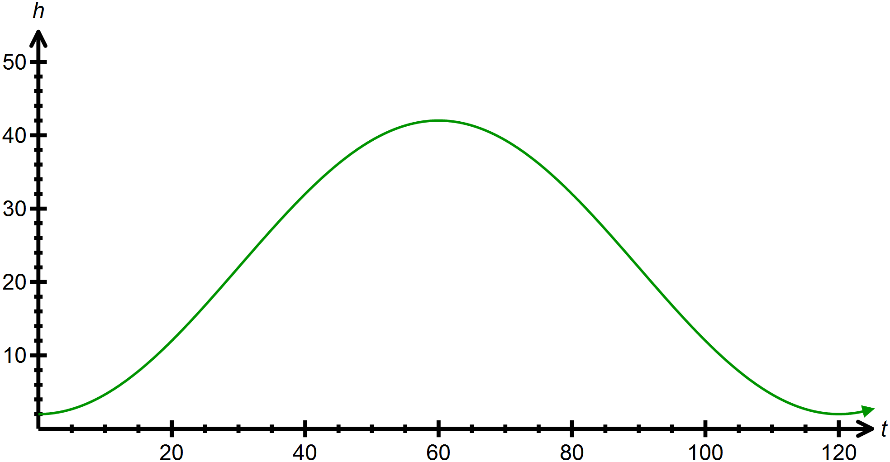









1. Hence or otherwise find the cosine equation of the graph.

